GOVERNMENT OF KARNATAKA

DEPARTMENT OF TECHNICAL EDUCATION

BOARD OF TECHNICAL EDUCATION,BANGALORE



A PROJECT REPORT ON

“ONLINE CATERING SERVICES ”

**SUBMITTED BY :**

1. RANJITA I NAIK (447CS18038)
2. SOUMYASHRI (447CS18048)
3. ANKITA (447CS18008)
4. ADARSH ACHARI (447CS18003)
5. RAGHU R NAIK (447CS18036)

Project Guide:

Mr. V.T. Bhat (HOD, CSE Department)

Mr. Pradeep Hebbar (Lecturer, CSE Department)

“DEPARTMENT OF COMPUTER SCIENCE & ENGINEERING”

2020-2021

R. N. SHETTY RURAL POLYTECHNIC

MURUDESHWAR

(A UNIT OF R. N. SHETTY TRUST)

MURUDESHWAR, BHATKAL TALUKNORTH KANARA,

KARNATAKA STATE – 581350

**R.N. SHETTY RURAL POLYTECHNIC**

(A UNIT OF R.N.SHETTY TRUST)

**MURDESHWAR, BHATKAL TALUK**



Department of Computer Science and Engineering

**2020-2021**

CERTIFICATE

Certified that this project report entitled**“ONLINE CATERING SERVICES”**which is being Submitted by **Miss. Ranjita I Naik and Group** in partial fulfilment for the award of diploma in computer science and engineering during the year 2020-2021 is record of students own work carried out under my/our guidance.

It is certified that all corrections/suggestions indicated for internal Assessment have been incorporated in the report and one copy of it being deposited in the polytechnic library.

The project report has been approved as it satisfies the academic requirements in respect of Project work prescribed for the said diploma.

It is further understood that by this certificate the undersigned do not endorse or approve any statement made, opinion expressed or conclusion drawn there in but approve the project only for the purpose for which it is submitted.

**Mr. Pradeep Hebbar Mr. V. T. Bhat Mr. Santosh.A. R**

**(Guide) (Head of the Department) (Principal)**

**Examiners: 1. 2.**

**A Project Report On**

**OURROYALCATERERS**

**A Online Catering Service website**

**ACKNOWLDGEMENT**

This project being the first live project performed by us is an unforgettable experience. We would like to thank all of them who were associated with us during the course of this project.

We heartly thank our project guide Shri. Pradeep Hebbar who gave us the hope and inspiration to go ahead with the project.He has to answer all the question and an unconditional support that he gave us without which it would have been impossible to do this project successfully.

We specially thank our principal Sir. Santosh R.A for extending his kind co- operation during this project. We thank our H.O.D Shri. Venkataramana T Bhat for his encouragement and collaboration towards this project.

We would also like to express our sincere thanks to the lecture of Computer Science Department for their timely assistance during the course of his project. We are is also thankful to all Non-teaching staff of Department of Computer Science Engineering for providing us with all the necessary information and help needed for our project.

We also remember our parents who have helped us to achieve this objective. Last but not the least Almighty God for this blessing on us through this project work.

Thank you all once again …

**ABSTRACT**

The main aim of the project is to provide smart security to the customer.This system provides good and efficient information and thus making the service smarter.It is an interface for customer to browse the catalogue and order the food online.Using the power of internet multiple interest parties can order with complete security and control.

**INDEX**

**1.Introduction**

**2.Software and Hardware requirements**

**3.Source Code**

**4.Screenshots**

**5.Conclusion**

**Introduction:**

Catering is the business of providing food service to the people at the events that are conducted. It involves a lot of human work and the resources required. So managing of the resources and the people will become difficult. To solve these problems, the catering management system will be of great help. There are different kinds of catering like mobile catering, wedding catering, catering on ships and so on. The catering management system will help in maintaining the available people, resources and the timings well. It will help in the solving the problems related to the catering at the events that are conducted.

The catering involves a lot of risk. It can be related to the on-time delivery of the order, employee availability and so on. This catering management system will help in the smooth running of the business. It will be very helpful to the people who will be having orders for satisfying the needs of thousands of people. At that time all the matters related to the employee availability, resources maintains and time management plays a very important role.

Now a days the Food Service has been developing very highly, so to the Food Service Now the New System have been Arrived by the Name “Catering Service”. Whenever we observe catering, the primary issue that comes into people’s thoughts is food.

This application contains two types of users:

1.Admin

2.User

**Modules:**

**About us:**This module include about the catering services.

**Events:** This module includes description regarding the events for which the catering services are provided.

**Menus:** This module provides details of available food items along with the description, quantity, and price. There are different kinds of food category. Each category contains list of food items. Users will be able to view and select from the menus.

**Book Event:** This module allows the user to book an event. Orders must be made 7 days in advance. Once the order is placed user will be able to view the quotations of the respective order. Once the admin confirms the order, order will be processed else it will be cancelled. In case of cancellation by the user, user has to cancel the order before the due date i.e. 3 days prior to the delivery date. Admin has the rights to reject the order.

**Gallery:** This module includes images of food items.

**Contact us:** This module allows user to contact with catering services.

**Admin Login:**Using this module admin can view the events that are booked by login in to the system.

**Advantages:**

1. Accommodations for Dietary Restrictions.

2. Classic Food Options.

3. Cost-Effective Meal Planning.

4. Expert Help with Permits and Handling.

5. Positive Impressions of Your Company.

6. Reduced Stress and Responsibility.

7. Set Event Tone and Atmosphere.

8. Varying Menu Options.

**Hardware Requirement**

Processor :Intel (R) Core (TM)i3-7020U CPU @ 2.30GHz

RAM :1GB or More

Hard Disk :80 GB or More

Monitor :15” CRT, or LCD Monitor

Keyboard :Normal or Multimedia

Mouse :Compatible Mouse

**Software Requirement**

Operating System :Any OS (Windows XP or above)

Front-End :visual studio code

Back-End :appserv

**Source Code:**

**Index.php**

<?php

session_start();

require_once "functions.php" ;

$con=connect_my_db();

$uname=$_POST['user'];

$pwd=$_POST['pass'];

$sql="select * from users where email='$uname' AND pwd='$pwd' limit 1";

if(isset($_POST['login']))

{

if(mysqli_error($con))

echo "<br>Error = ".mysqli_error($con);

$result=mysqli_query($con,$sql);

$login=mysqli_num_rows($result)==1&&(!preg_match('/([\'"])/', $_POST['pass']));

if($login)

{

$userinfo=mysqli_fetch_assoc($result);

$_SESSION['userid']=$userinfo['id'];

$_SESSION['user']=$_POST['desg'];

header("location:orders.php");

exit();

}

if(!$login)

{

echo '<script type="text/javascript"> alert("You Have Entered Incorrect Email/Password !!!"); </script>';

}

}

if(isset($_POST['ordernow']))

{

$name=$_POST['name'];

$event=$_POST['event'];

$date=$_POST['date'];

$guests=$_POST['guests'];

$phno=$_POST['phno'];

$message=$_POST['message'];

$order = "INSERT INTO orders(`name`,`event`,`date`,`guests`,`phno`,`message`) VALUES ('$name','$event','$date','$guests','$phno','$message')";

$order=mysqli_query($con,$order);

if(!$order)

{ echo mysqli_error($con);

}

}

?>

<html>

<head>

<title>our royal caterers </title>

<style>

body,html{background-color:rgb(30,10,10); margin:0; overflow-x:hidden; background-image:url('bg.jpg'); background-repeat:no-repeat; background-size:100%;position:center; height:100%;width:100%;}

.none{padding:2%;}

.row{width:100%;}

.orc{font-size:large;}

.col-15{width:15%; float:left;}

.col-15r{width:17%; float:right;}

.col-60{width:60%; float:left;} .left{float;}

.info{color:white;text-align:left; padding:1%; background-color:rgba(000,000,000,0.700);z-index:2; }

h4{color:white;text-align:left;}

.login{border-color:#CBB26A; border-radius:25px; padding:5%; background:inherit; color:white;}

.login:hover{color:chartreuse; cursor:pointer;}

/* navbar */

.navbarlog { text-align:center; overflow: hidden; padding:1%; background-color:rgba(000,000,000,0.600); box-shadow: 0px 8px 16px 0px rgba(0,0,0,1.0);}

.navbar{ text-align:center; overflow: hidden; padding:2%; background-color:rgba(000,000,000,0.600); box-shadow: 0px 8px 16px 0px rgba(0,0,0,1.0);}

.navbarorc{ text-align:center; overflow: hidden; padding:1%; background-color:rgba(000,000,000,0.600); box-shadow: 0px 8px 16px 0px rgba(0,0,0,1.0);}

.navbarorc a { font-size: 16px; color:white; text-align: center; padding: 14px 16px; text-decoration: none; }

.navbar a { font-size: 16px; color:white; text-align: center; padding: 14px 16px; text-decoration: none; }

.navbar a:hover {color:#CBB26A;}

/* closable tabs */

input[type=text],[type=number],input[type=password], select, textarea { width: 50%; padding: 12px; border: 1px rgb(255, 81, 0);box-shadow: 0px 1px 2px 0px rgba(0,0,0,1.0); border-radius: 4px; }

u{color:blue;}

.box{background-image:url('login.jpg');background-repeat:no-repeat;background-size:100%; height:100%; width:100%; top:0%; z-index:10; position:absolute; padding:3%; color:white; font-size:20px; background-color:rgba(000,000,000,1.0); box-shadow: 0px 8px 16px 0px rgba(0,0,0,1.0); border-radius:15px;}

.boxg{background-size:100%; height:100%; width:100%; top:0%; z-index:10; position:absolute; padding:3%; color:white; font-size:20px; background-color:rgba(000,000,000,0.9); box-shadow: 0px 8px 16px 0px rgba(0,0,0,1.0); border-radius:15px;}

.boxe{background-image:url('bg5.jpg');background-repeat:no-repeat; background-size:100%; background-position:center; width:100%; top:0%; z-index:10; position:absolute; padding:3%; color:white; font-size:20px; background-color:rgba(000,000,000,1.0); box-shadow: 0px 8px 16px 0px rgba(0,0,0,1.0); border-radius:15px;}

.btn{background-color:inherit; color:black; font-size:16px; border:inherit;}

.col-25 { float: left; width: 15%; margin-top: 10px;padding:1%;}

.col-75 { float: left; width: 75%; margin-top: 6px; }

.con{width:15%; padding:1%; background-color:rgb(255, 0, 0); color:white; border:none; border-radius:15px; box-shadow:0px 3px 8px 0px rgba(0,0,0,1.0);}

.con:hover{ background-color:blue; font-size:16px; color:white; box-shadow: 0px 8px 16px 0px rgba(0,0,0,1.0);}

.conhead{ color:white; border:15px;}

.left{ float:left; } .right{ float:right; }

.loghead{padding:1%; color:#CBB26A; border:15px;}

.mybtn{width:25%; padding: 2%; background-color:red; color:white; border:none; border-radius:15px; box-shadow:0px 3px 8px 0px rgba(0,0,0,1.0);}

.mybtn:hover{ background-color:blue; color:white; box-shadow: 0px 8px 16px 0px rgba(0,0,0,1.0);}

.padding{padding-left:5%; padding-top:5%;} .padtop{ padding-top:30%; } .padrit{padding-right:5%; padding-top:2%;} .padleft{padding-left:5%; padding-top:2%;}

.padl{padding-left:40%; padding-top:20%; padding-right:15%;}

span{cursor:pointer;}

/* footer */

.subpart{display: flex; }

.subpart .field:first-child{ margin-right: 10px; }

.subpart .field:last-child{ margin-left: 10px; }

.footer{width:100%; padding-top:5%; font-size:large; padding-bottom:5%; background-color:rgba(000,000,000,0.600); color:white; border-radius:5px;}

.footer a{text-decoration:none; color:white; cursor:pointer;}

.footer a:hover{color:#CBB26A;}

.colmn{width:32%; padding:2%;}

.copy{text-align:center; width:100%; text-align:center; padding-top:1%; padding-bottom:1%; background-color:rgba(000,000,000,0.600); color:white; border-radius:5px;}

.copy a{text-decoration:none; color:white;}

.copy a:hover{color:#CBB26A;}

/*scrollbar */

::-webkit-scrollbar {width: 0px;} /* width */

::-webkit-scrollbar-track { box-shadow: inset 0 0 5px inherit; border-radius: 10px; }/* Track */

::-webkit-scrollbar-thumb { background: inherit; border-radius: 10px; }/* Handle */

::-webkit-scrollbar-thumb:hover { background: inherit; }/* Handle on hover */

</style>

</head>

<body>

<!-- ------------------------- navbar start ------------------------------ -->

<div class="bg">

<div class="none"></div>

<center>

<div class="row">

<div class="navbarorc col-15">

<a class="left" href=""><b class="orc">Our Royal Caterers</b></a>

</div>

<div class="navbar col-60" >

<a href="about.html">About Us</a>

<a href="menu.html"> Menu</a>

<a href="events.html"> Events</a>

<a onclick="openTabs('Gallery')">Gallery</a>

<a href="contact.php">Contact Us</a>

</div>

<div class="navbarlog col-15r">

<button onclick="openTabs('login')" class="login">Admin Login</button>

<button onclick="openTabs('order')" class="login">Book an Event</button>

</div>

</div>

</center>

</div>

<!-- ------------------------- navbar end ------------------------------ -->

<!-- ------------------------- gallery start ------------------------------ -->

<div id="Gallery" class="boxg tabs" style="display:none">

<span onclick="this.parentElement.style.display='none'" class="left">&#10060;</span><br><br>

<center><h1>Gallery</h1></center><hr>

<?php

$imagesDirectory = "gallery/";

if(is_dir($imagesDirectory))

{

$opendirectory = opendir($imagesDirectory);

while (($image = readdir($opendirectory)) !== false)

{

if(($image == '.') || ($image == '..'))

{

continue;

}

$imgFileType = pathinfo($image,PATHINFO_EXTENSION);

if(($imgFileType == 'jpg') || ($imgFileType == 'png'))

{

echo "<img src='gallery/".$image."' width='200'> ";

}

?> &nbsp; &nbsp; &nbsp; &nbsp;

<?php

}

closedir($opendirectory);

}

?>

</div>

<!-- ------------------------- gallery end ------------------------------ -->

<!-- ------------------------- login start --------------------------- -->

<center>

<div id="login" class="box tabs" style="display:none">

<span class="left" onclick="closetabs();"> &#10060; </span>

<header class="loghead">

<h1>Log In</h1>

</header> <hr class="hr">

<form method="POST">

<div class="padding">

<label for="user">Username :</label>

<input type="text" id="user" name="user" placeholder="User Name" />

</div>

<div class="padding">

<label for="pass">Password :</label>

<input type="password" id="pass" name="pass" placeholder="Password" />

</div>

<div class="padding">

<input type="submit" class="mybtn" value="Login" name="login">

</div>

<br>

</form>

</div>

</center>

<!-- ------------------------- login end --------------------------- -->

<!-- ------------------------- event start --------------------------- -->

<center>

<div id="order" name="order" class="boxe tabs" style="display:none">

<span class="left" onclick="closetabs();"> &#10060; </span>

<header class="loghead">

<h1>Book an Event Now</h1>

</header> <hr class="hr">

<form method="post"><br>

<div class="row">

<div class="col-25">

<label for="name">Full Name</label>

</div>

<div class="col-75">

<input type="text" id="name" name="name" placeholder="Your full name..">

</div>

</div><br><br><br>

<div class="row">

<div class="col-25">

<label for="event">Event</label>

</div>

<div class="col-75">

<input type="text" id="event" name="event" placeholder="Type of event ..">

</div>

</div><br><br><br>

<div class="row">

<div class="col-25">

<label for="eventdate">Date of Event</label>

</div>

<div class="col-75">

<input type="text" id="date" name="date" placeholder="Date of event ..">

</div>

</div><br><br><br>

<div class="row">

<div class="col-25">

<label for="guest">No of Guests</label>

</div>

<div class="col-75">

<input type="number" id="guests" name="guests" placeholder="No of Guests ..">

</div>

</div><br><br><br>

<div class="row">

<div class="col-25">

<label for="pno">Phone Number</label>

</div>

<div class="col-75">

<input type="text" id="phno" name="phno" placeholder="Your phone number ..">

</div>

</div><br><br><br>

<div class="row">

<div class="col-25">

<label for="message">Message</label>

</div>

<div class="col-75">

<textarea id="message" name="message" placeholder="Write Message Here.." style="height:100px"></textarea>

</div>

</div><br><br><br>

<div class="padding">

<input type="submit" class="con" style="float:left;" value="Book now" name="ordernow" />

</div>

</form>

</div>

</center>

<!-- ------------------------- event end --------------------------- -->

<!-- ------------------------- info start --------------------------- -->

<div class="none"></div>

<div class="none"></div>

<div class="none"></div>

<div class="info">

<h4>Formal vegetarian meals</h4>

<p>

are usually served in a particular order and required to be consumed in a particular order as well.<br>

These meals are served on Plantain leaves or Mutuka leaves, dry Tendu-like leaves staples together into big circular discs. <br>

First accompaniments are served which includes a variety of Palya, Kosambari, sweet-savory gojju, hot spicy chutney Pickles,<br>

bajji, bonda, vada, Papads. The first course alternated between sweets and rice preparation.<br>

</p>

<p>

The second course is a set of curries to be consumed with rice.

It generally starts with Tovve, a mild lentil dish laced with ghee, Majjige Huli, vegetables simmered in a mild yogurt<br>

sauce, followed by Huli, lentils and vegetables spiced and tempered with ghee, mustard, asafoetida and curry leaves.<br>

This is followed by Tili Saaru which is a thin lentil stock spiced and laced with ghee and curry leaves. <br>

The final course of the meal is rice and curd with pickles.

</p>

<p>

Buttermilk is also served to be consumed at the end of the meal.

</p>

<p>

A typical simple household meal consists of pickle, salad (kosambri), vegetable dish (palle) or lentil dish (kaal),<br>

chutneys, curd, bread (chapati, rotti etc), dessert (this does not have to be eaten at the end), rice and different <br>

curries/soups (saar) and finally curd rice.

</p>

</div>

<div class="none"></div>

<!-- ------------------------- info end --------------------------- -->

<!-- ------------------------- footer start --------------------------- -->

<div class="footer subpart">

<div class="colmn">

<h4>Contact</h4><br>

<p><b>Address :</b> Our Royal Caterers,<br>

&emsp;&emsp;&emsp;&emsp; pposite to murudeshwar arch,<br>

&emsp;&emsp;&emsp;&emsp; near railway station<br>

&emsp;&emsp;&emsp;&emsp; murudeshwar,bhatkal tq,<br>

&emsp;&emsp;&emsp;&emsp; Uttara Kannada,Karnataka ,India

</p>

<p><b>E-mail :</b> ourroyalcaterers@gmail.com</p>

<p>&nbsp;<b>Ph-no :</b> 9876543210</p>

</div>

<div class="colmn">

<h4>Account</h4><br>

<a href="menu.php"> Menu</a><br>

<a href="events.html"> Events</a><br>

<a href="gallery.php">Gallery</a><br>

</div>

<div class="colmn">

<h4>Information</h4><br>

<a href="aboutus.php">About Us</a><br>

<a href="contact.php">Contact Us</a><br>

<a href="pp.html">Privacy Policy</a><br>

<a href="tc.html">Terms & Conditions</a><br>

</div>

</div><br><br>

<div class="copy">

<p >&copy; Copyrights <a href=""><b>Our Royal Caterers</b></a>. All Rights Reserved. </p>

</div>

<div class="none"></div>

<!-- ------------------------- footer end --------------------------- -->

</body>

<script>

// closable tabs

function closetabs(tabsName)

{

var i;

var x = document.getElementsByClassName("tabs");

for (i = 0; i < x.length; i++)

{

x[i].style.display = "none";

}

document.getElementById("bokon").style.display = "block";

}

function openTabs(tabsName)

{

var i;

var x = document.getElementsByClassName("tabs");

for (i = 0; i < x.length; i++)

{

x[i].style.display = "none";

}

document.getElementById(tabsName).style.display = "block";

}

// modal login

<?php

if ($error)

{

echo"alert('$error');";

} ?>

</script>

</html>

**Contact.php**

<?php

session_start();

require_once "functions.php" ;

$con=connect_my_db();

if(isset($_POST['contact']))

{

$name=$_POST['name'];

$pno=$_POST['pno'];

$message=$_POST['message'];

$insert = "INSERT INTO messages(`name`,`pno`,`messages`) VALUES ('$name','$pno','$message')";

$insert=mysqli_query($con,$insert);

if(!$insert)

{

echo mysqli_error($con);

}

}

?>

<html>

<head>

<title>Contact Us</title>

<style>

body{ padding-bottom:2%;margin:0; background-image:url('bg2.jpg'); background-repeat:no-repeat; background-size:cover;position:center; height:100%;width:100%;}

/* closable tabs */

input[type=text],input[type=password], select, textarea{ width: 50%; padding: 12px; border: 1px rgb(255, 81, 0);box-shadow: 0px 1px 2px 0px rgba(0,0,0,1.0); border-radius: 4px; }

u{color:blue;}

.box{top:0%; z-index:10; position:absolute; padding-top:1%; padding-right:3%; padding-bottom:3%; padding-left:3%; width:93%; height:90%; color:Black; font-size:20px; background: inherit; border-radius:15px;}

.btn{background-color:inherit; color:black; font-size:16px; border:inherit;}

.col-25 { float: left; width: 15%; margin-top: 10px; }

.col-75 { float: left; width: 75%; margin-top: 6px; }

.con{width:15%; padding:1%; background-color:rgb(255, 0, 0); color:white; border:none; border-radius:15px; box-shadow:0px 3px 8px 0px rgba(0,0,0,1.0);}

.con:hover{ background-color:blue; font-size:16px; color:white; box-shadow: 0px 8px 16px 0px rgba(0,0,0,1.0);}

.conhead{ color:white; border:15px;}

.left{ float:left; } .right{ float:right; } .yellow{color:yellow;}

.loghead{padding:0.5%; color:white; border:15px;}

label{color:white; }

.mybtn{width:25%; padding: 2%; background-color:rgb(255, 0, 0); color:white; border:none; border-radius:15px; box-shadow:0px 3px 8px 0px rgba(0,0,0,1.0);}

.mybtn:hover{ background-color:blue; font-size:16px; color:white; box-shadow: 0px 8px 16px 0px rgba(0,0,0,1.0);}

.padding{padding-left:5%; padding-top:5%;} .padtop{ padding-top:30%; } .padrit{padding-right:5%; padding-top:2%;} .padleft{padding-left:5%; padding-top:2%;}

.padl{padding-left:40%; padding-top:20%; padding-right:15%;}

span{cursor:pointer;}

</style>

</head>

<body>

<center>

<div id="contactus" class="box tabs">

<header class="conhead">

<span class="left" onclick="closetabs();"> &#10060; </span>

<h1>Contact Us</h1>

</header>

<label class="yellow"> Email : ourroyalcaterers@gmail.com </label>

<hr class="hr">

<form method="post"><br>

<div class="row">

<div class="col-25">

<label for="name">Name</label>

</div>

<div class="col-75">

<input type="text" id="name" name="name" placeholder="Your name..">

</div>

</div><br><br><br>

<div class="row">

<div class="col-25">

<label for="pno">Phone Number</label>

</div>

<div class="col-75">

<input type="text" id="pno" name="pno" placeholder="Your pno ID..">

</div>

</div><br><br><br>

<div class="row">

<div class="col-25">

<label for="message">Message</label>

</div>

<div class="col-75">

<textarea id="message" name="message" placeholder="Write Message Here.." style="height:100px"></textarea>

</div>

</div><br><br><br>

<div class="padding">

<input type="submit" class="con" style="float:left;" value="Submit" name="contact">

</div>

</form>

</div>

</center>

</body>

<script>

function closetabs()

{

location.replace("index.php")

}

</script>

</html>

**About.html**

<html>

<head>

<title>About</title>

<style>

body,html{margin:0; background-image:url('bg.jpg');background-color:rgb(30,10,10); background-repeat:no-repeat; background-size:100%;position:center; height:100%;width:100%;}

fieldset{width:90%; border-radius:5px; border-color:#01FF00;}

span{cursor:pointer;}

.none{padding:2%;}

.box{position:absolute; padding-left:3%;padding-right:3%;padding-bottom:3%; width:94%; color:white; font-size:20px; background-color:rgba(000,000,000,0.700); box-shadow: 0px 8px 16px 0px rgba(0,0,0,1.0); border-radius:15px;}

.mybtn{width:10%; padding:1%; background-color:#7b3d11; color:white; border:none; border-radius:5px; box-shadow:0px 3px 8px 0px rgba(0,0,0,1.0);}

.mybtn:hover{background-color:#F7642D; font-size:16px; color:white; box-shadow: 0px 8px 16px 0px rgba(0,0,0,1.0);}

.h1{ color:white; border-radius:15px; text-align: center;}

input[type=text],[type=number], select, textarea { width: 100%; padding: 12px; border: 1px solid #ccc; border-radius: 4px; resize: vertical; }

.del{background:#7b3d11; color:white;border:none;border-radius:15px; width:100%;height:150%;}

.del[type=submit]:hover{background:red;}

.right{float:right;} .left{float:left;}

.info{color:white;text-align:left; padding:1%; background-color:rgba(000,000,000,0.700); z-index:2; height:95%; }

</style>

</head>

<body>

<div class="info">

<div class="none">

<span class="left" onclick="closetabs();"> &#10060; </span>

</div>

<h2>Who We Are</h2>

<p>We are a company that offers catering, services in South Karnataka. </p>

<p>Tired of planning the same boring dinner menu for your family and guests? Tired of looking at other catering companies that only offer one cookie-cutter menu? Want to stop spending time in the kitchen and start enjoying being a part of your party? Would you like to enhance a special occasion with memorable and exciting food?</p>

<p>Well, you have come to the right place! We take the time to fully detail and understand your unique needs, which we creatively execute with a highly experienced staff. Bella Personal Chef, Catering, and Event Design aims to make your special event not only memorable, but as easy and stress-free as possible! Just take a look at what some of our guests say about our services by reading the testimonials they have written.</p>

<p>We know how important food is when it comes to creating memories! You want your food to not only be delicious, but unique and affordable as well. One of the many things we love the most at Bella’s is establishing a relationship with our clients, getting to know them, and understanding their vision for the perfect dinner event. We can create the menu that will bring to life our clients vision and will be enjoyed by all of the guests.</p>

</div>

</body>

<script>

function closetabs()

{

location.replace("index.php")

}

</script>

</html>

**Events.php**

<html>

<head>

<title>Events</title>

<style>

body,html{text-align:center; background-color:rgb(10, 0, 143); margin:0; overflow-x:hidden; background-image:url('eventsbg.jpg'); background-size:100%;position:center; height:100%;width:100%;}

h1{font-size: 100px; color:lavenderblush;}

h2{color:chartreuse;}

span{cursor:pointer;}

.left{float:left;}

.none{padding:2%;}

.box{background-size:100%; height:100%; width:100%; top:0%; z-index:10; position:absolute; padding:3%; color:white; font-size:20px; background-color:rgba(000,000,000,0.3); box-shadow: 0px 8px 16px 0px rgba(0,0,0,1.0); border-radius:15px;}

</style>

</head>

<body>

<div class="none"></div>

<div class="box">

<span class="left" onclick="closetabs();"> &#10060; </span>

<h1>Events</h1>

<h2>Birthday Party</h2>

<h2>Kitty Party</h2>

<h2>Send off Party</h2>

<h2>Get Together Party</h2>

<br>

<h2>Brahmopadesham Event</h2>

<h2>Marriage Event</h2>

<h2>Naming Ceremony</h2>

<h2>wedding Anniversary</h2>

<br>

<h2>Death Anniversary</h2>

<br>

<h2>Cultural Event</h2>

<h2>Temple Event</h2>

<div class="none"></div>

</div>

</body>

<script>

function closetabs()

{

location.replace("index.php")

}

</script>

</html>

**functions.php**

<?php

function connect_my_db()

{

$host="localhost";

$user="root";

$password="12345678";

$db="orc";

$con=mysqli_connect($host,$user,$password,$db) or die("Sorry unable to connect");

return $con;

}

?>

**gallery.php**

<?php

// Getting uploaded file

$file = $_FILES["file"];

// Uploading in "uplaods" folder

move_uploaded_file($file["tmp_name"], "gallery/" . $file["name"]);

// Redirecting back

header("Location: " . $_SERVER["HTTP_REFERER"]);

?>

**img.php**

<html>

<?php

session_start();

require_once "functions.php" ;

$con=connect_my_db();

$result=mysqli_query($con,"SELECT * FROM users where id=".$_SESSION['userid']);

if(mysqli_error($con))

echo "<br>Error = ".mysqli_error($con);

if(isset($_POST['messages']))

{

header('Location: messages.php');

}

if(isset($_POST['orders']))

{

header('Location: orders.php');

}

if(isset($_POST['logout']))

{

session_destroy();

header('Location: index.php');

}

?>

<head>

<title>Upload Images</title>

<style>

a{color:white;}

body,html{margin:0; background-image:url('bg.jpg'); background-repeat:no-repeat; background-size:cover;position:center; height:100%;width:100%;}

fieldset{width:90%; border-radius:5px; border-color:#01FF00;}

.bg{position:fixed; overflow-x:hidden; background-image:url('back.jpg'); background-repeat:no-repeat; background-size:cover;position:center; height:100%;width:100%;}

.box{position:absolute; padding-left:3%;padding-right:3%;padding-bottom:3%; width:94%; color:white; font-size:20px; background-color:rgba(000,000,000,0.700); box-shadow: 0px 8px 16px 0px rgba(0,0,0,1.0); border-radius:15px;}

.mybtn{width:10%; padding:1%; background-color:#7b3d11; color:white; border:none; border-radius:5px; box-shadow:0px 3px 8px 0px rgba(0,0,0,1.0);}

.mybtn:hover{background-color:#F7642D; font-size:16px; color:white; box-shadow: 0px 8px 16px 0px rgba(0,0,0,1.0);}

.h1{ color:white; border-radius:15px; text-align: center;}

input[type=text],[type=number], select, textarea { width: 100%; padding: 12px; border: 1px solid #ccc; border-radius: 4px; resize: vertical; }

input[type=file], select { width: 50%; padding: 12px; border: 1px rgb(255, 81, 0);box-shadow: 0px 1px 2px 0px rgba(0,0,0,1.0); border-radius: 4px; }

.right{float:right;} .left{float:left;}

@media screen and (max-width: 600px) { .col-15, .col-65,input[type=submit],select { width: 100%; margin-top: 10; } select{height:20%;} }

</style>

</head>

<body>

<div class="bg">

<div class="box">

<h1 class="h1">Upload Images</h1>

<form method="post">

<div>

<br>

<input type="submit" value="messages" name="messages" class="mybtn left" />

<input type="submit" value="orders" name="orders" class="mybtn left" />

<input type="submit" value="logout" name="logout" class="mybtn right" />

<br><br><br><br>

</div>

</form>

<center>

<fieldset>

<legend>Upload Images</legend>

<?php

if($result && mysqli_num_rows($result)>0)

{

$userinfo=mysqli_fetch_assoc($result);

if($userinfo['desg']==1 || $userinfo['desg']==2)

{

?>

<form method="POST" action="gallery.php" enctype="multipart/form-data">

<input type="file" name="file"/>

<input type="submit" value="Upload" class="mybtn" />

</form>

<?php

$files = scandir("gallery");

for( $a = 2 ; $a < count($files); $a++)

{

?>

<p>

<a href="delete.php?name=gallery/<?php echo $files[$a]; ?>" style="color: red;"> Delete</a>

<a href="gallery/<?php echo $files[$a];?>" ><?php echo $files[$a];?></a>&nbsp&nbsp&nbsp&nbsp

</p>

<?php

}

}

}

?>

</fieldset>

</center>

</div>

</div>

</body>

</html>

**Menu.html**

<html>

<head>

<title>Menu</title>

<style>

body,html{background-color:rgb(30,10,10); margin:0; padding-left:2%; overflow-x:hidden; background-image:url('menucard.jpg'); background-size:100%;position:center; height:100%;width:100%;}

h1{font-size: 50px; color:white;}

h2{color:#fff; text-decoration: underline;}

h3{color:#CBB26A;}

span{cursor:pointer;}

.none{padding:2%;}

</style>

</head>

<body>

<div class="none">

<span class="left" onclick="closetabs();"> &#10060; </span>

</div>

<h1>Menu</h1>

<p>

<h2>EXTRA ITEMS SWEETS</h2>

<h3>Jangiri<br>

Laddu<br>

Mysore PakJangiri<br>

Laddu<br>

Mysore Pak<br>

Kesari Bath<br>

Pineapple Kesari Bath<br>

Chakkara Pongal<br>

Kasi Halwa<br>

Carrot Halwa<br>

Ashoka Halwa<br>

Bombay Halwa<br>

Rava Ladu<br>

Dry Jamoon<br>

Jamoon with Syrup<br>

Elai Adai<br>

Cham Cham<br>

Rasa Gulla<br>

Malai Sandwich<br>

Champakali<br>

Milk Peda<br>

Milk Cake<br>

Coconut Burfi<br>

Badam Burfi<br>

Peni<br>

Chiroti<br>

Maaladu<br>

Bournvita Cake<br>

Chocolate Cake<br>

3 Colour Cake<br>

Chandra Har<br>

Makmal Poori<br>

Bhadusha<br>

Coconut Boli<br>

Paruppu Boli<br>

Badam Puri</h3>

</p>

<p>

<h2>HOT DRINKS</h2>

<h3>Coffee<br>

Tea<br>

Horlicks<br>

Bournvita<br>

Boost<br>

Badam Milk<br>

Complan<br>

Viva</h3>

</p>

<p>

<h2>PACCHADI</h2>

<h3> Cucumber<br>

Ladies Finger<br>

Tomato<br>

Boondi<br>

Pomegranate<br>

Carrot,Cucumber<br>

Carrot,Tomato<br>

Pineapple<br>

Pumpkin</h3>

</p>

<p>

<h2>COOL DRINKS</h2>

<h3>Orange Juice<br>

Lime Juice<br>

Grape Juice<br>

Pineapple Juice<br>

Sugarcane Juice<br>

Rasna<br>

Moosambi Juice<br>

Apple Juice</h3>

</p>

<p>

<h2>AYASAMP</h2>

<h3> Paaladai<br>

Milk<br>

Shadashadayam<br>

Wheat Pradavan<br>

Semiya Payasam<br>

Gasa Gasa<br>

Sabbakki<br>

Kadala Paruppu<br>

Jack fruit<br>

Rava Payasam</h3>

</p>

<p>

<h2>KOOTU</h2>

<h3> Chenai & Elavan<br>

Chou Chou<br>

Kootu Kari(Yam & Kabul Chenna)<br>

Brinjal Potato<br>

Mixed Vegetables<br>

Kalan, Olan, Aviyal, Elishery</h3>

</p>

<p>

<h2>PODIMAS</h2>

<h3> Raw Plantain<br>

Potato</h3>

</p>

<p>

<h2>KOSMARI</h2>

<h3> Sweet<br>

Salt</h3>

</p>

<p>

<h2>PORIYAL</h2>

<h3> Beans<br>

Chape Avarekai<br>

Plantain<br>

Brinjal<br>

Ladies Finger<br>

Alasande<br>

Cabbage<br>

Mixed Vegetables</h3>

</p>

<p>

<h2>USULI</h2>

<h3> Beans<br>

Cabbage<br>

Kottha Varanga<br>

Mixed Vegetables</h3>

</p>

<p>

<h2>KARA KARI</h2>

<h3> Plantain<br>

Potato<br>

Brinjal<br>

Miniyam</h3>

</p>

<p>

<h2>SAMBAR</h2>

<h3> Ladies Finger<br>

Drumstickv<br>

Mixed Vegetable<br>

Onion<br>

Brinjal<br>

Poricha Kootu<br>

Bitter gourd pitla<br>

Molagootal<br>

Moru Kuzhambu</h3>

</p>

<p>

<h2>RASAM</h2>

<h3>Tomato<br>

Lemon<br>

Mysore<br>

Pineapple<br>

Pepper<br>

Garlic</h3>

</p>

<p>

<h2>VADAS</h2>

<h3>Urud Vada<br>

Paruppu Vada<br>

Cabbage vada<br>

Onion vada<br>

Curd vada<br>

Rasam vada<br>

Sambar vada<br>

Polla vada/ thattai</h3>

</p>

<p>

<h2>CHUTNEY</h2>

<h3> Coconut<br>

Red Chillie<br>

Pudina<br>

Onion<br>

Ginger<br>

Tomato<br>

Coriander<br>

Kadala Paruppu</h3>

</p>

<p>

<h2>BONDA</h2>

<h3>Uddin Bonda<br>

Potato<br>

Mixed vegetable<br>

Mangalore<br>

Rasam bonda</h3>

</p>

<p>

<h2>BAJJI</h2>

<h3>Plantain<br>

Onion<br>

Potato<br>

Brinjal<br>

Chillie<br>

Paneer<br>

Bread</h3>

</p>

<p>

<h2>PAKODA</h2>

<h3> Onion<br>

Mixed veg<br>

Cutlet<br>

Samosa</h3>

</p>

<p>

<h2>CHIPS</h2>

<h3>Banana-sweet/salt<br>

Potato<br>

Yam<br>

Moru Molagai<br>

Masala papad<br>

Appalam<br>

Pappadam</h3>

</p>

<p>

<h2>MANCHOORIAN</h2>

<h3> Gobi Manchoori<br>

Baby Corn Manchoori<br>

Mushroom Manchoori</h3>

</p>

<p>

<h2>North Indian dishes</h2>

<h3> Romali Roti<br>

Butter Nan<br>

Masala Nan<br>

Masala Roti<br>

Patura<br>

Paneer Butter Masala<br>

Paneer Masala<br>

Chenna Masala<br>

Mixed veg kurma<br>

Kadai Sabji<br>

Malai kofta<br>

Navaratna kurma<br>

Veg Thavabaji<br>

Veg Shai kurma<br>

Green Peas Masala<br>

Dal Makani</h3>

</p>

<p>

<h2>BREAKFAST</h2>

<h3> Idli<br>

Plain Dosa<br>

Masala Dosa<br>

Set Dosa<br>

Onion Dosa<br>

Rava Dosa<br>

Adai<br>

Veg.upma<br>

Karabath<br>

Coconut Sevai<br>

Lemon Sevai<br>

Rava Idli<br>

Pongal<br>

Poori<br>

Chappathi</h3>

</p>

<p>

<h2>SOUPS</h2>

<h3> Tomato<br>

Baby Corn</h3>

</p>

<p>

<h2>RICE ITEMS</h2>

<h3> Vegetable Pulav<br>

Peas Pulav<br>

Veg.Biriyani<br>

Jeera Rice<br>

Bisibele Bath<br>

Coconut Rice<br>

Lemon Rice<br>

Puliyogare<br>

Pudina Rice<br>

Menthya Rice<br>

Vaangi Bath<br>

Curd Rice</h3>

</p>

<p>

<h2>CHATS</h2>

<h3> Bhel Puri<br>

Pani Puri<br>

Masala Puri<br>

Aloo Puri<br>

Dahi Puri<br>

Samosa Masala<br>

Sev Puri</h3>

</p>

<p>

<h2>PICKLES</h2>

<h3> Mango<br>

Gooseberry<br>

Lemon<br>

Mixed vegetable<br>

Puli Inji<br>

Molagai Podi</h3>

</p>

<p>

<h2>CHEER ITEMS</h2>

<h3> Murukku 5/7/9 lines<br>

Mullu murukku<br>

Then Kozhal<br>

Adhi Rasam<br>

Laddu<br>

Mysore Pak<br>

Milk Theratipal<br>

Coconut Theratipal<br>

Appam</h3>

</p>

<p>

<h2>GOPURAM</h2>

<h3>Cashew nut<br>

Manoharam<br>

Laddu<br>

Mysore pak<br>

Mitai<br>

Ground nut<br>

Fried grams<br>

Biscuits<br>

Diamond sugar<br>

Badam</h3>

</p>

<p>

<h2>ICE CREAM VARIETIES</h2>

<h3> Vanilla<br>

Strawberry<br>

Chocolate<br>

Butterscotch<br>

Pista<br>

Mango</h3>

</p>

<p>

<h2>EXTRA ITEMS</h2>

<h3> Vegetable Salad<br>

Cut Fruit<br>

Fruit Salad</h3>

</p>

<p>

<h2></h2>

</p>

</body>

<script>

function closetabs()

{

location.replace("index.php")

}

</script>

</html>

**Messages.php**

<!DOCTYPE html>

<html>

<head>

<title>Messages</title>

<style>

body,html{margin:0; background-image:url('bg.jpg'); background-repeat:no-repeat; background-size:cover;position:center; height:100%;width:100%;}

table{border-radius:5px; border-color:blue; width:50%; color:white;}

th,td{border-radius:5px; text-align:center; padding:0.1%; color:white;}

th{padding:1%;}

fieldset{width:90%; border-radius:5px; border-color:#01FF00;}

.bg{position:fixed; overflow-x:hidden; background-image:url('back.jpg'); background-repeat:no-repeat; background-size:cover;position:center; height:100%;width:100%;}

.box{position:absolute; padding-left:3%;padding-right:3%;padding-bottom:3%; width:94%; color:white; font-size:20px; background-color:rgba(000,000,000,0.700); box-shadow: 0px 8px 16px 0px rgba(0,0,0,1.0); border-radius:15px;}

.mybtn{width:10%; padding:1%; background-color:#7b3d11; color:white; border:none; border-radius:5px; box-shadow:0px 3px 8px 0px rgba(0,0,0,1.0);}

.mybtn:hover{background-color:#F7642D; font-size:16px; color:white; box-shadow: 0px 8px 16px 0px rgba(0,0,0,1.0);}

.h1{ color:white; border-radius:15px; text-align: center;}

input[type=text],[type=number], select, textarea { width: 100%; padding: 12px; border: 1px solid #ccc; border-radius: 4px; resize: vertical; }

.del{background:#7b3d11; color:white;border:none;border-radius:15px; width:100%;height:150%;}

.del[type=submit]:hover{background:red;}

.right{float:right;} .left{float:left;}

@media screen and (max-width: 600px) { .col-15, .col-65,input[type=submit] { width: 100%; margin-top: 10; } select{height:20%;} }

</style>

</head>

<body>

<div class="bg">

<div class="box">

<?php

session_start();

require_once "functions.php" ;

$con=connect_my_db();

$result=mysqli_query($con,"SELECT * FROM users where id=".$_SESSION['userid']);

if(mysqli_error($con))

echo "<br>Error = ".mysqli_error($con);

if(isset($_POST['logout']))

{

session_destroy();

header('Location: indexday.php');

}

if($result && mysqli_num_rows($result)>0)

{

$userinfo=mysqli_fetch_assoc($result);

if($userinfo['desg']==2)

{

$rec = mysqli_query($con,"SELECT * FROM messages");

$msg = mysqli_fetch_array($rec);

//------------------------delete message-------------------------------

if(isset($_POST['mdelete']))

{

$id = $_POST['mdelete'];

$del = mysqli_query($con,"delete from messages where id = $id");

}

//----------------------------------------------------------------------

if(isset($_POST['gallery']))

{

header('Location: img.php');

}

if(isset($_POST['orders']))

{

header('Location: orders.php');

}

if(isset($_POST['logout']))

{

session_destroy();

header('Location: index.php');

}

?>

<br><h1 class="h1">All Messages</h1>

<form method="post">

<div>

<br>

<input type="submit" value="gallery" name="gallery" class="mybtn left" />

<input type="submit" value="orders" name="orders" class="mybtn left" />

<input type="submit" value="logout" name="logout" class="mybtn right" />

<br><br><br><br>

</div>

</form>

<center>

<form method='post'>

<fieldset>

<legend>Messages</legend>

<table border="3" cellpadding=10>

<tr>

<th>Name</th>

<th>Email</th>

<td style="font-weight:bold;">Message</th>

<th>Delete</th>

</tr>

<?php

$records = mysqli_query($con,"SELECT * FROM messages"); // fetch data from database

while($data = mysqli_fetch_array($records))

{

?>

<tr>

<td><?php echo $data['name']; ?>&nbsp;&nbsp;&nbsp;</td>

<td><?php echo $data['pno']; ?>&nbsp;&nbsp;</td>

<td><?php echo $data['messages']; ?>&nbsp;&nbsp;</td>

<td><button name="mdelete" id="mdelete" value="<?php echo $data['id']; ?>" class="del">Delete</button></td>

</tr>

<?php

}

?>

</table>

</form>

<?php mysqli_close($con); // close connection ?>

</fieldset>

</center>

<?php

}

}

?>

</div>

</div>

</body>

<script>

// closable tabs

function closetabs(tabsName)

{

var i;

var x = document.getElementsByClassName("tabs");

for (i = 0; i < x.length; i++)

{

x[i].style.display = "none";

}

document.getElementById("bokon").style.display = "block";

}

function openTabs(tabsName)

{

var i;

var x = document.getElementsByClassName("tabs");

for (i = 0; i < x.length; i++)

{

x[i].style.display = "none";

}

document.getElementById(tabsName).style.display = "block";

}

</script>

</html>

**Orders.php**

<!DOCTYPE html>

<html>

<head>

<title>Orders</title>

<style>

body,html{margin:0; background-image:url('bg.jpg'); background-repeat:no-repeat; background-size:cover;position:center; height:100%;width:100%;}

table{border-radius:5px; border-color:blue; width:100%; color:white;}

th,td{border-radius:5px; text-align:center; color:white;}

th{padding:1%;}

fieldset{width:90%; border-radius:5px; border-color:#01FF00;}

.bg{position:fixed; overflow-x:hidden; background-image:url('back.jpg'); background-repeat:no-repeat; background-size:cover;position:center; height:100%;width:100%;}

.box{position:absolute; padding-left:3%;padding-right:3%;padding-bottom:3%; width:94%; color:white; font-size:20px; background-color:rgba(000,000,000,0.700); box-shadow: 0px 8px 16px 0px rgba(0,0,0,1.0); border-radius:15px;}

.mybtn{width:10%; padding:1%; background-color:#7b3d11; color:white; border:none; border-radius:5px; box-shadow:0px 3px 8px 0px rgba(0,0,0,1.0);}

.mybtn:hover{background-color:#F7642D; font-size:16px; color:white; box-shadow: 0px 8px 16px 0px rgba(0,0,0,1.0);}

.h1{ color:white; border-radius:15px; text-align: center;}

input[type=text],[type=number], select, textarea { width: 100%; padding: 12px; border: 1px solid #ccc; border-radius: 4px; resize: vertical; }

.del{background:#7b3d11; color:white;border:none;border-radius:15px; width:100%;height:150%;}

.del[type=submit]:hover{background:red;}

.right{float:right;} .left{float:left;}

@media screen and (max-width: 600px) { .col-15, .col-65,input[type=submit] { width: 100%; margin-top: 10; } select{height:20%;} }

</style>

</head>

<body>

<div class="bg">

<div class="box">

<?php

session_start();

require_once "functions.php" ;

$con=connect_my_db();

$result=mysqli_query($con,"SELECT * FROM users where id=".$_SESSION['userid']);

if(mysqli_error($con))

echo "<br>Error = ".mysqli_error($con);

if(isset($_POST['logout']))

{

session_destroy();

header('Location: indexday.php');

}

if($result && mysqli_num_rows($result)>0)

{

$userinfo=mysqli_fetch_assoc($result);

if($userinfo['desg']==2)

{

$rec = mysqli_query($con,"SELECT * FROM orders");

$msg = mysqli_fetch_array($rec);

//------------------------delete message-------------------------------

if(isset($_POST['mdelete']))

{

$id = $msg['id'];

$del = mysqli_query($con,"delete from orders where id = $id");

}

//----------------------------------------------------------------------

if(isset($_POST['gallery']))

{

header('Location: img.php');

}

if(isset($_POST['messages']))

{

header('Location: messages.php');

}

if(isset($_POST['logout']))

{

session_destroy();

header('Location: index.php');

}

?>

<br><h1 class="h1">All Orders</h1>

<form method="post">

<div>

<br>

<input type="submit" value="gallery" name="gallery" class="mybtn left" />

<input type="submit" value="messages" name="messages" class="mybtn left" />

<input type="submit" value="logout" name="logout" class="mybtn right" />

<br><br><br><br>

</div>

</form>

<center>

<form method='post'>

<fieldset>

<legend>Orders</legend>

<table border="3" cellpadding=10>

<tr>

<th>Name</th>

<th>Event</th>

<th>Date of Event</th>

<th>Number of Guests</th>

<th>Phone number</th>

<td style="font-weight:bold;">Message</th>

<th>Delete</th>

</tr>

<?php

$records = mysqli_query($con,"SELECT * FROM orders"); // fetch data from database

while($data = mysqli_fetch_array($records))

{

?>

<tr>

<td><?php echo $data['name']; ?>&nbsp;&nbsp;&nbsp;</td>

<td><?php echo $data['event']; ?>&nbsp;&nbsp;</td>

<td><?php echo $data['date']; ?>&nbsp;&nbsp;</td>

<td><?php echo $data['guests']; ?>&nbsp;&nbsp;</td>

<td><?php echo $data['phno']; ?>&nbsp;&nbsp;</td>

<td><?php echo $data['message']; ?>&nbsp;&nbsp;</td>

<td><button name="mdelete" id="mdelete" value="<?php echo $data['id']; ?>" class="del">Delete</button></td>

</tr>

<?php

}

?>

</table>

</form>

<?php mysqli_close($con); // close connection ?>

</fieldset>

</center>

<?php

}

}

?>

</div>

</div>

</body>

<script>

// closable tabs

function closetabs(tabsName)

{

var i;

var x = document.getElementsByClassName("tabs");

for (i = 0; i < x.length; i++)

{

x[i].style.display = "none";

}

document.getElementById("bokon").style.display = "block";

}

function openTabs(tabsName)

{

var i;

var x = document.getElementsByClassName("tabs");

for (i = 0; i < x.length; i++) {

x[i].style.display = "none"; }

document.getElementById(tabsName).style.display = "block"; }

</script>

</html>

**Screenshot**

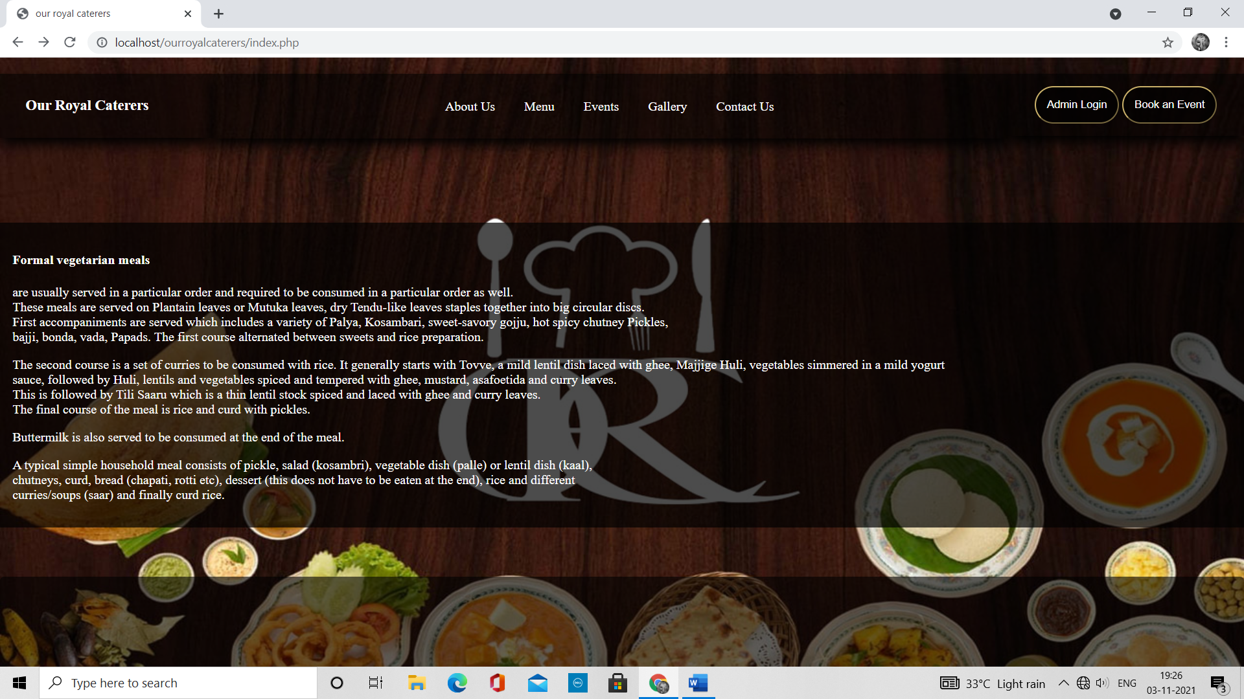

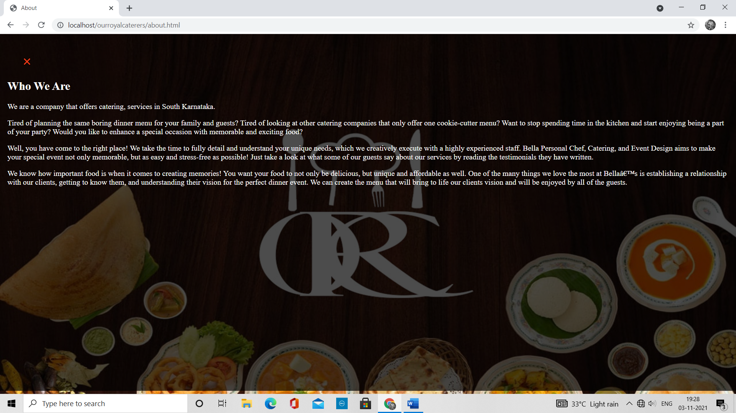

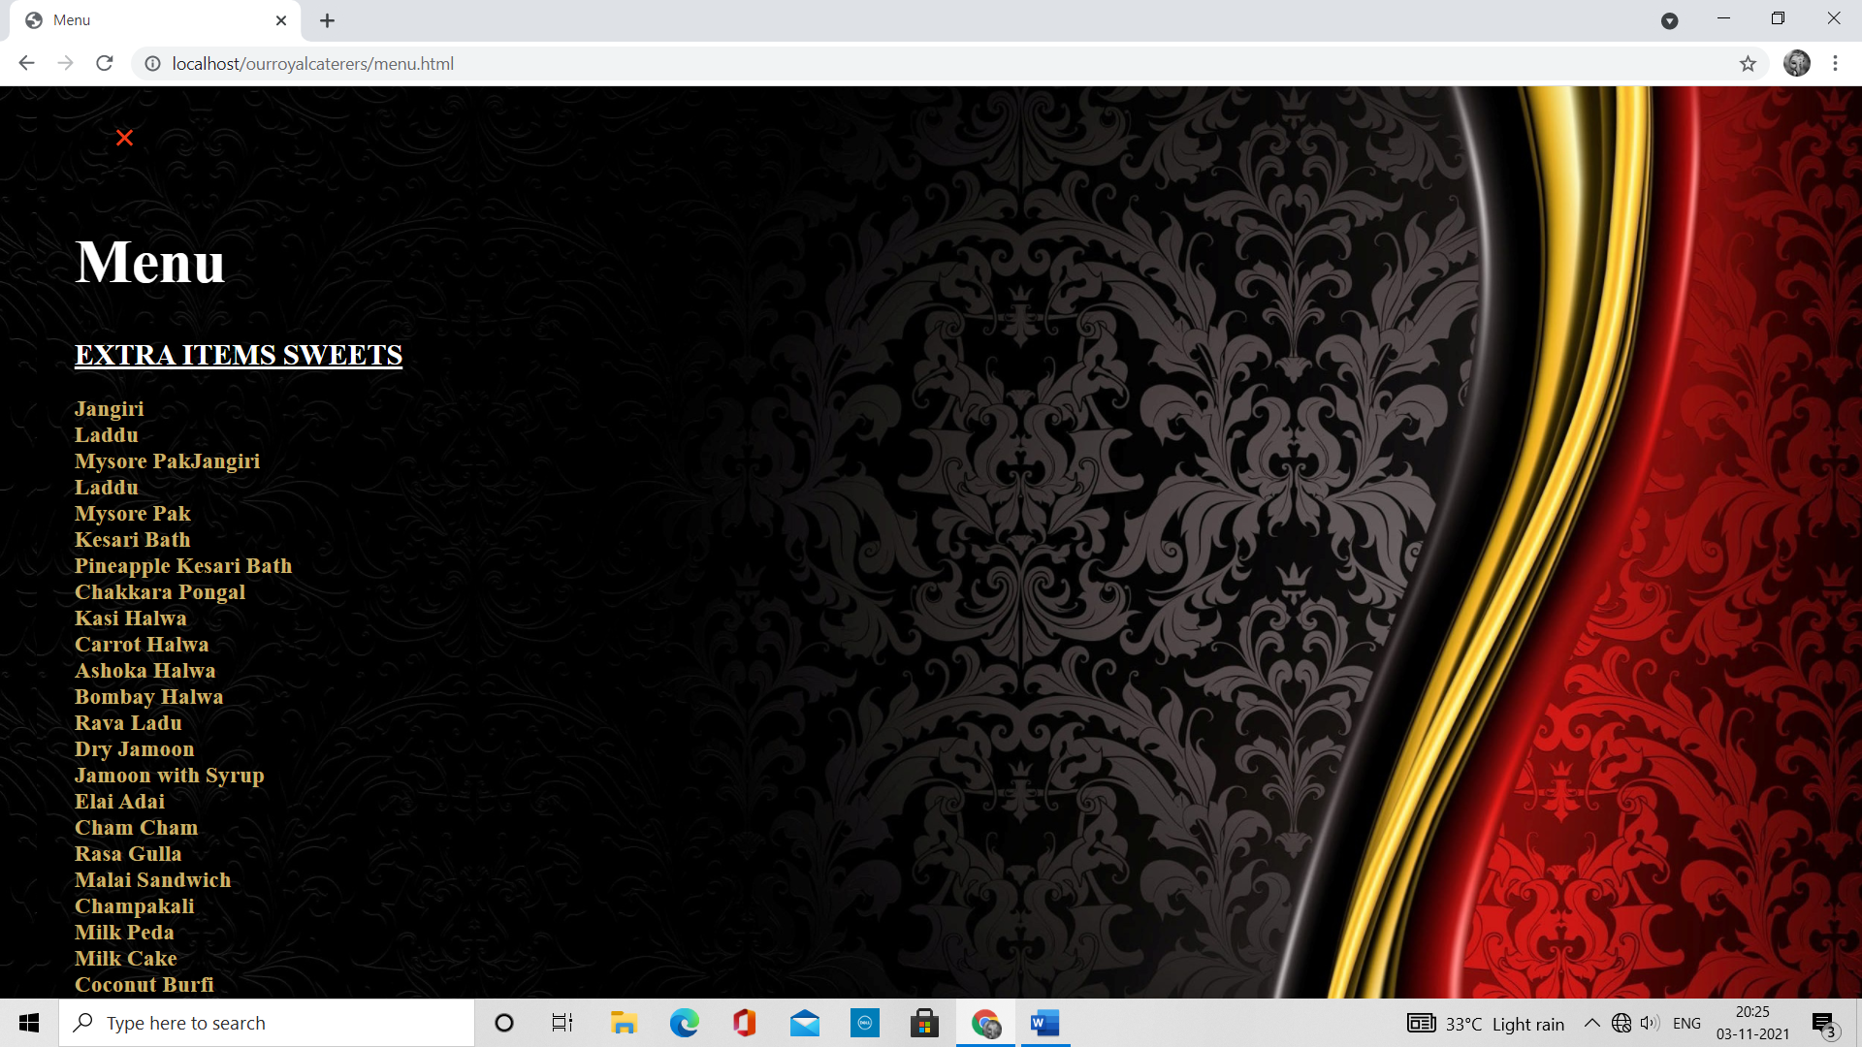

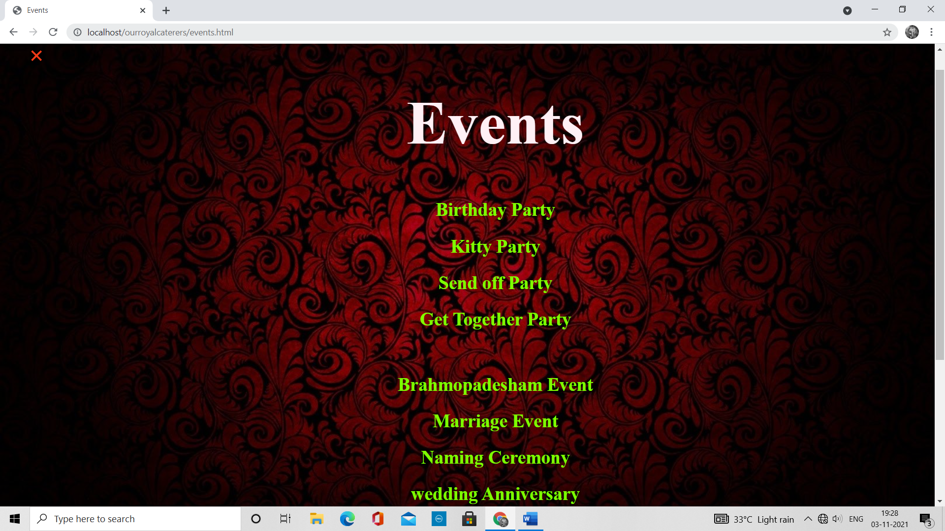

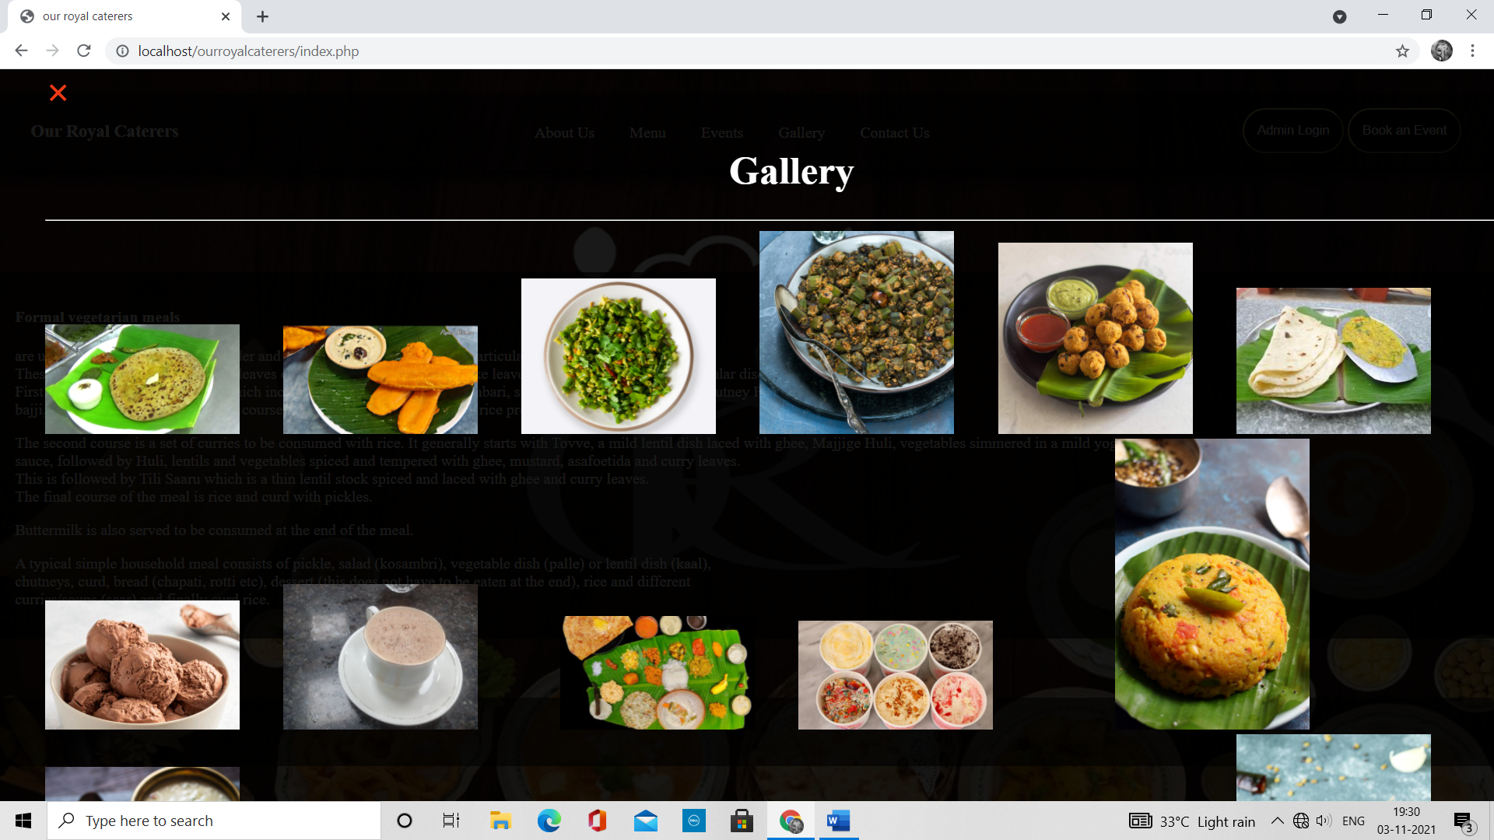

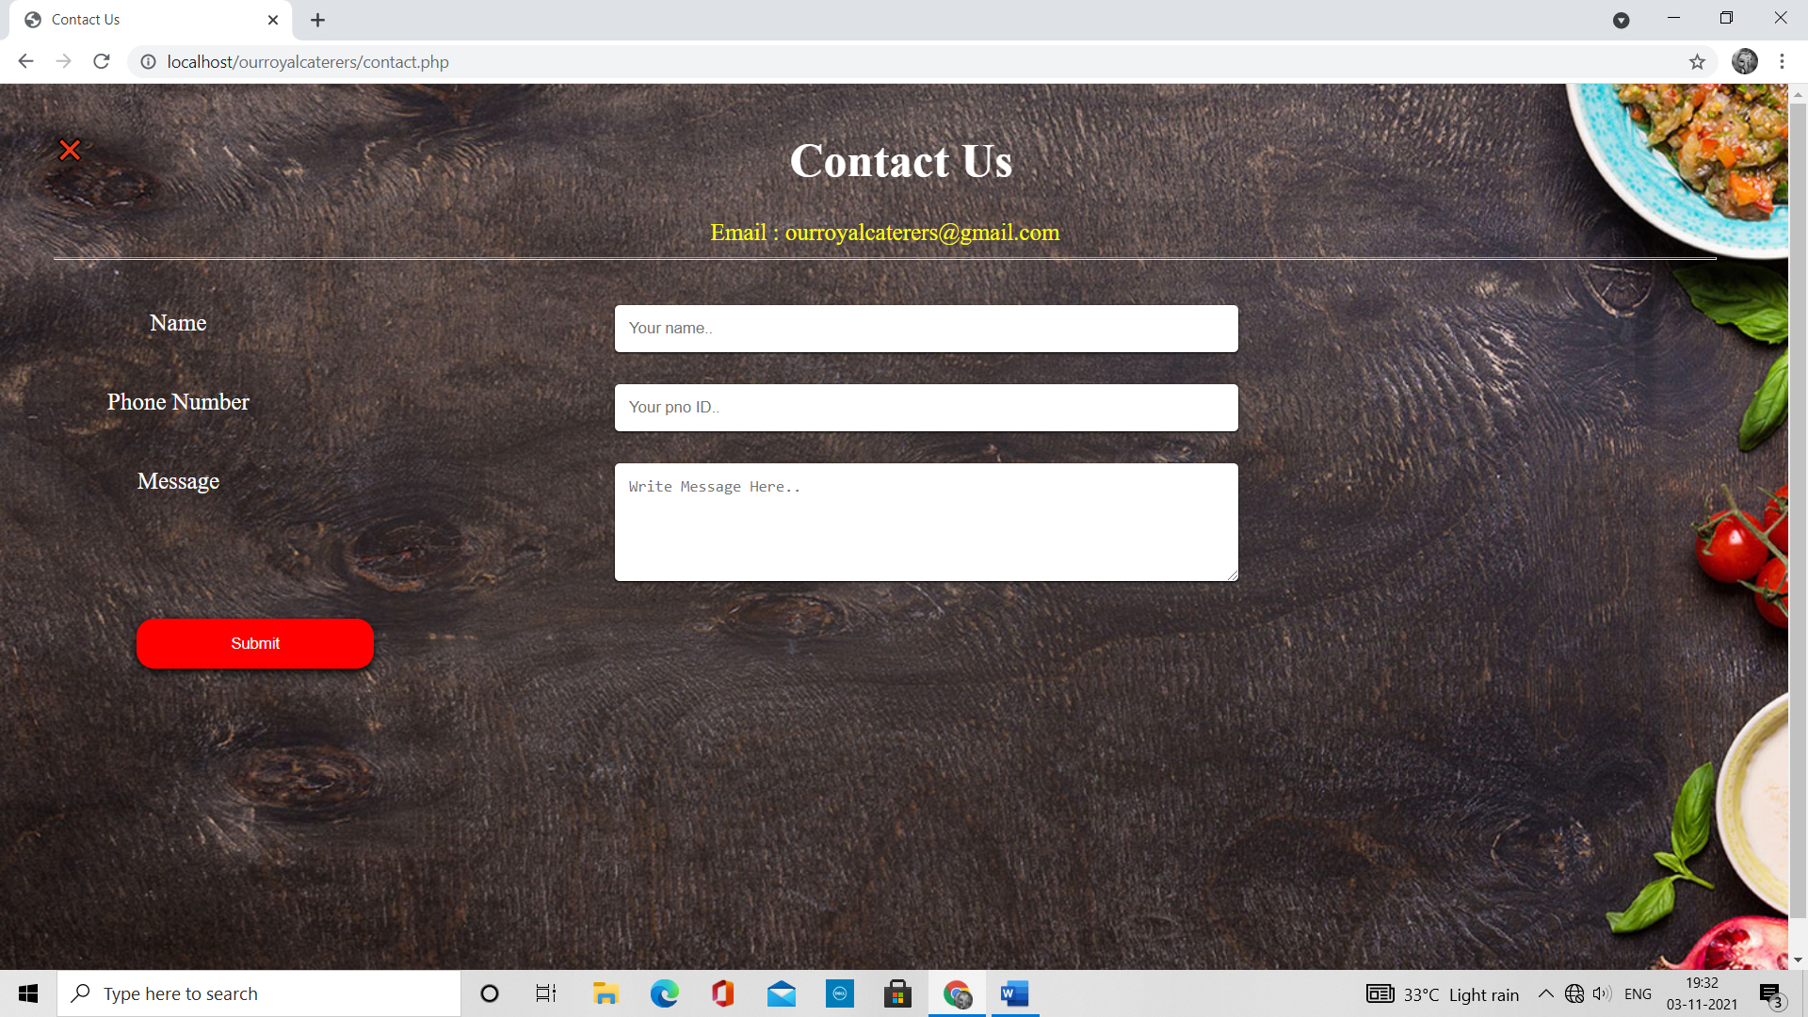

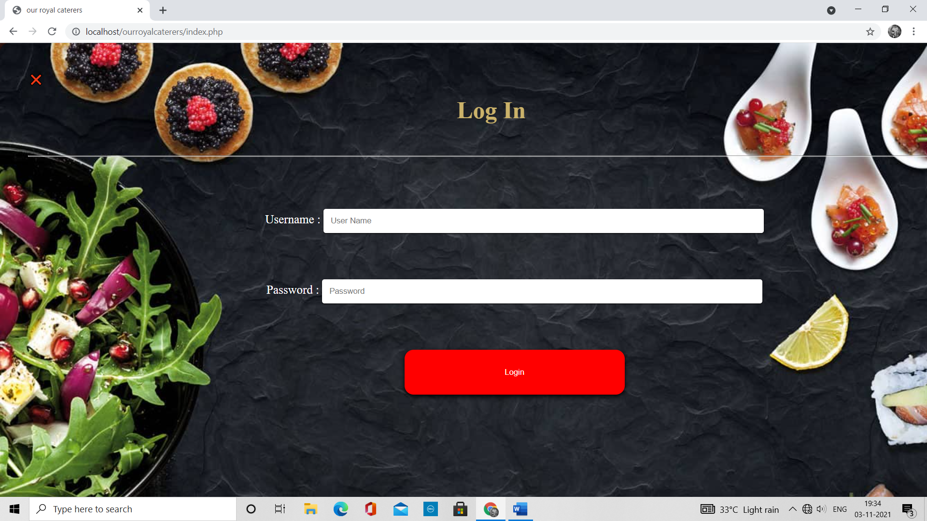

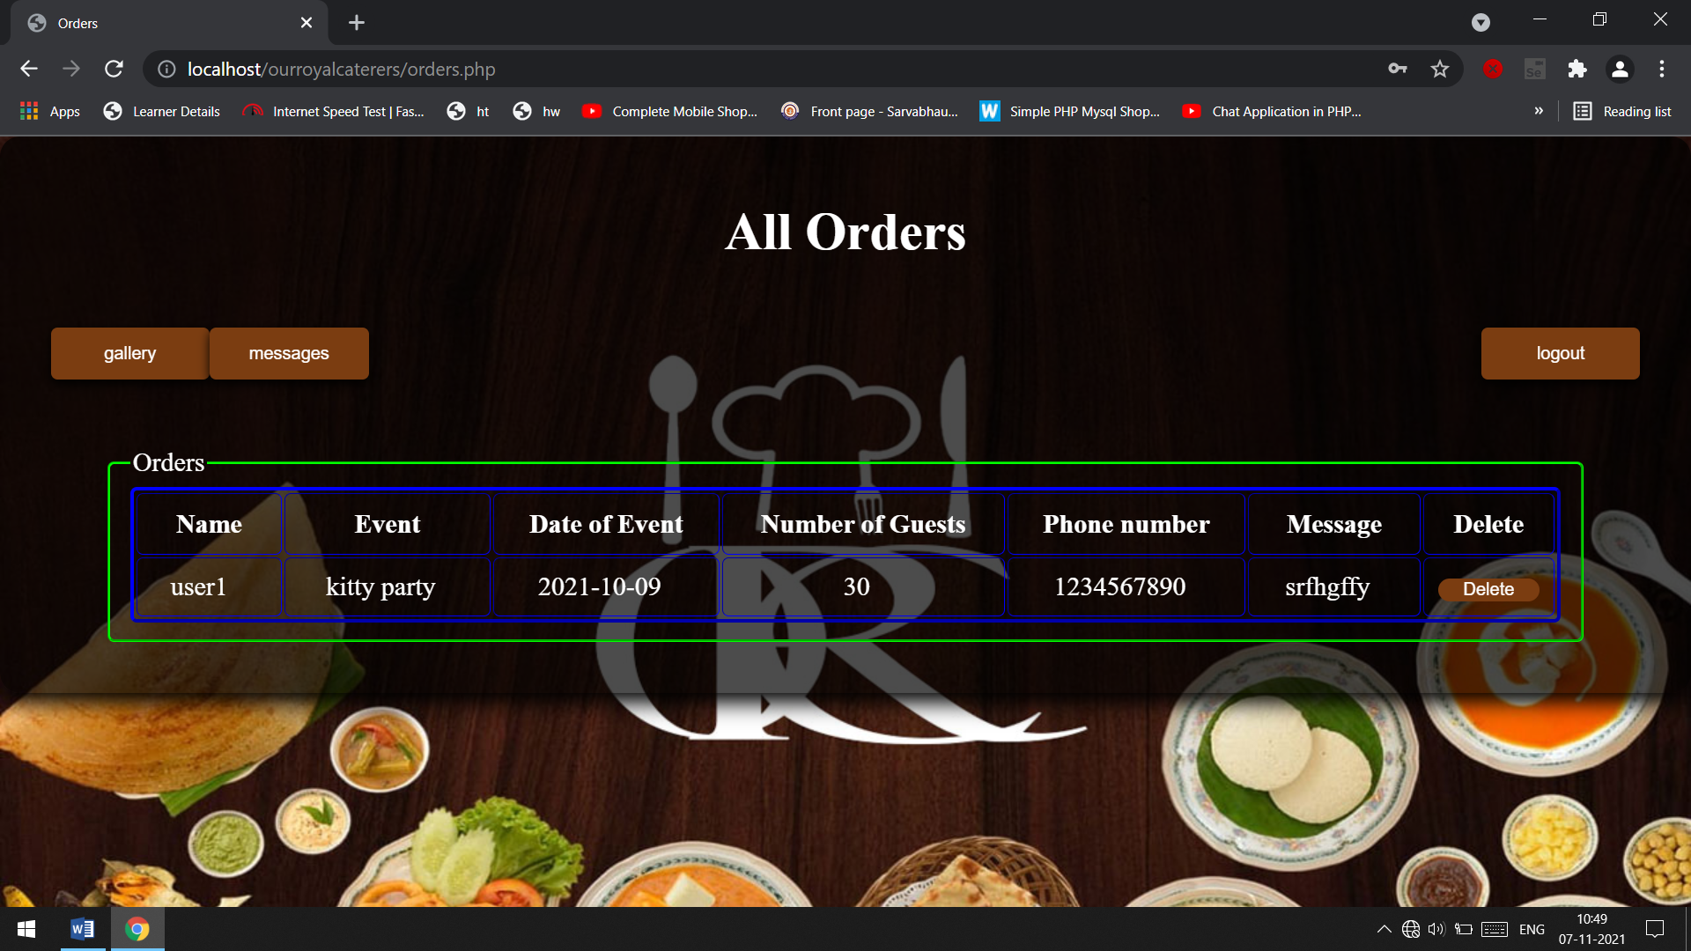

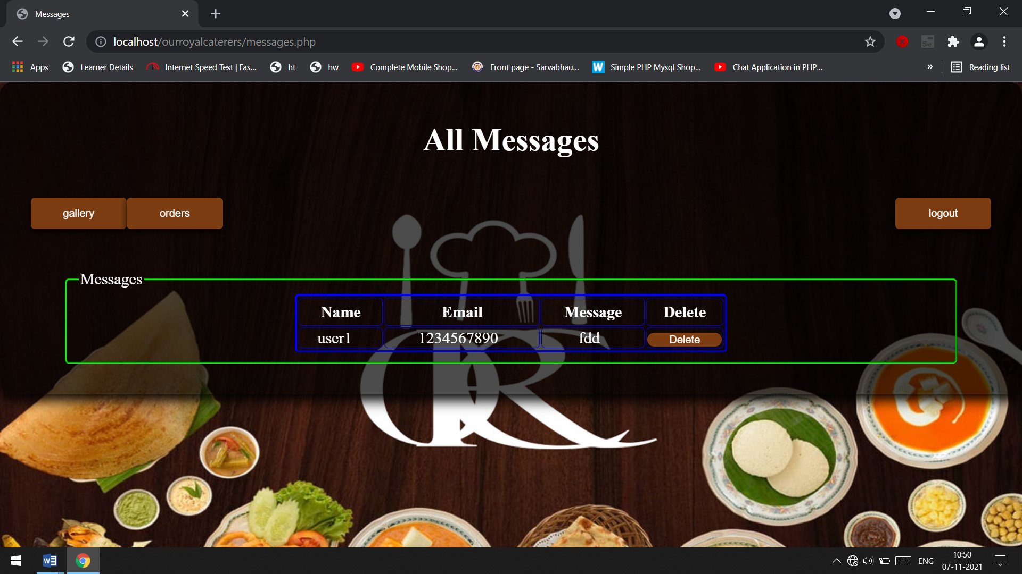

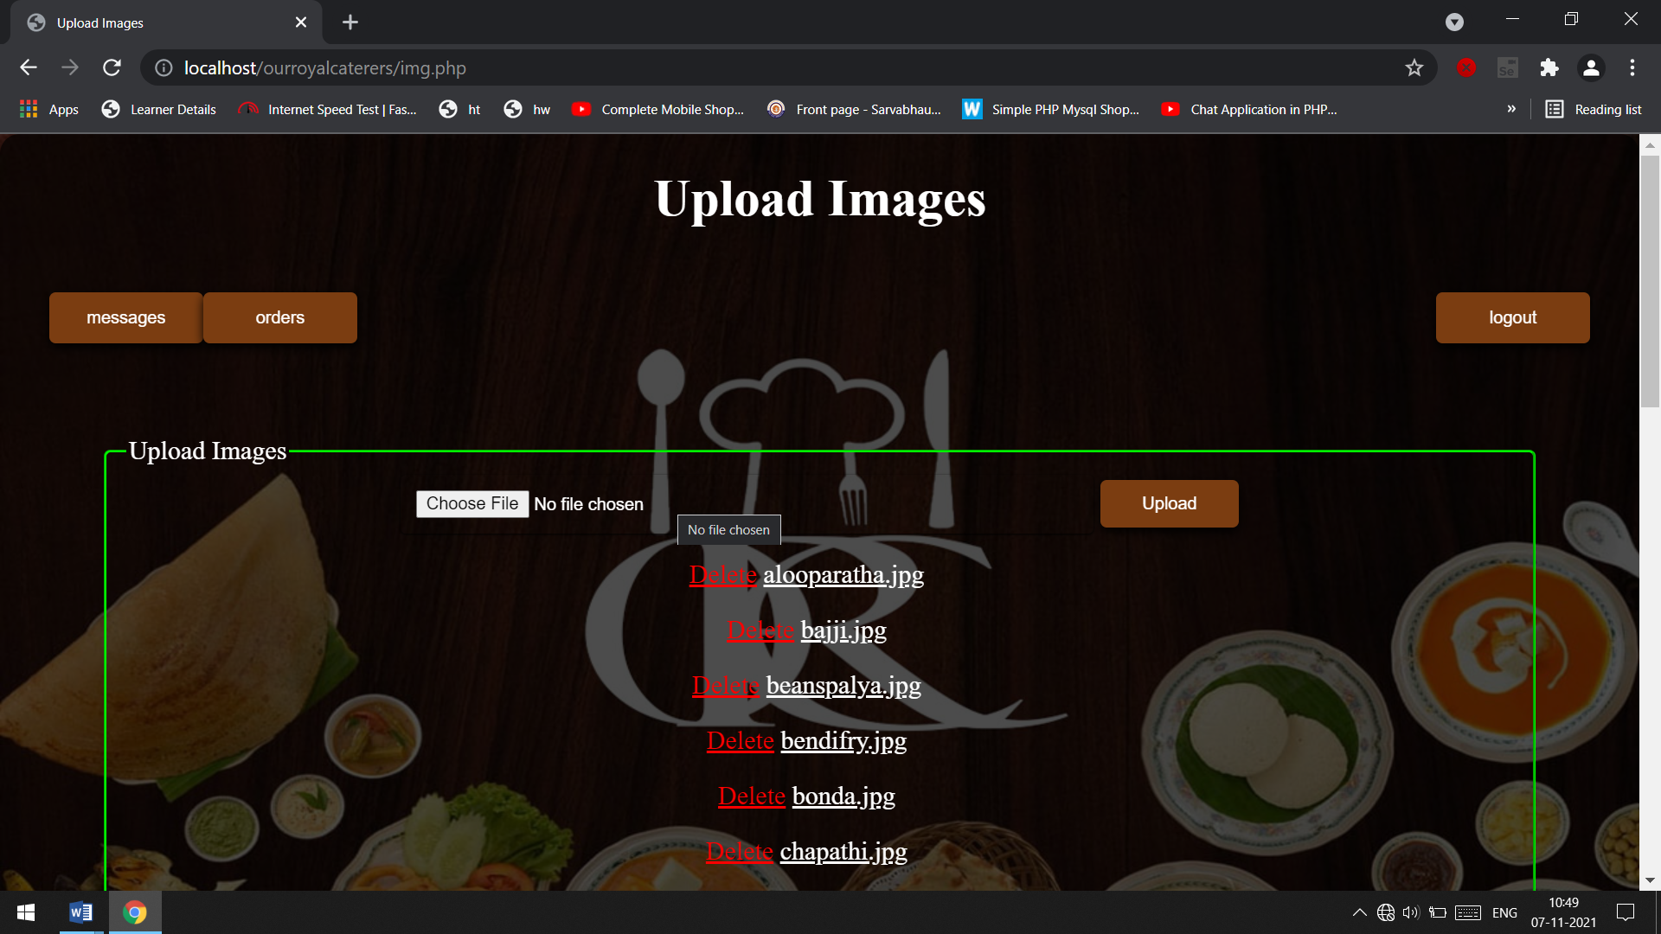

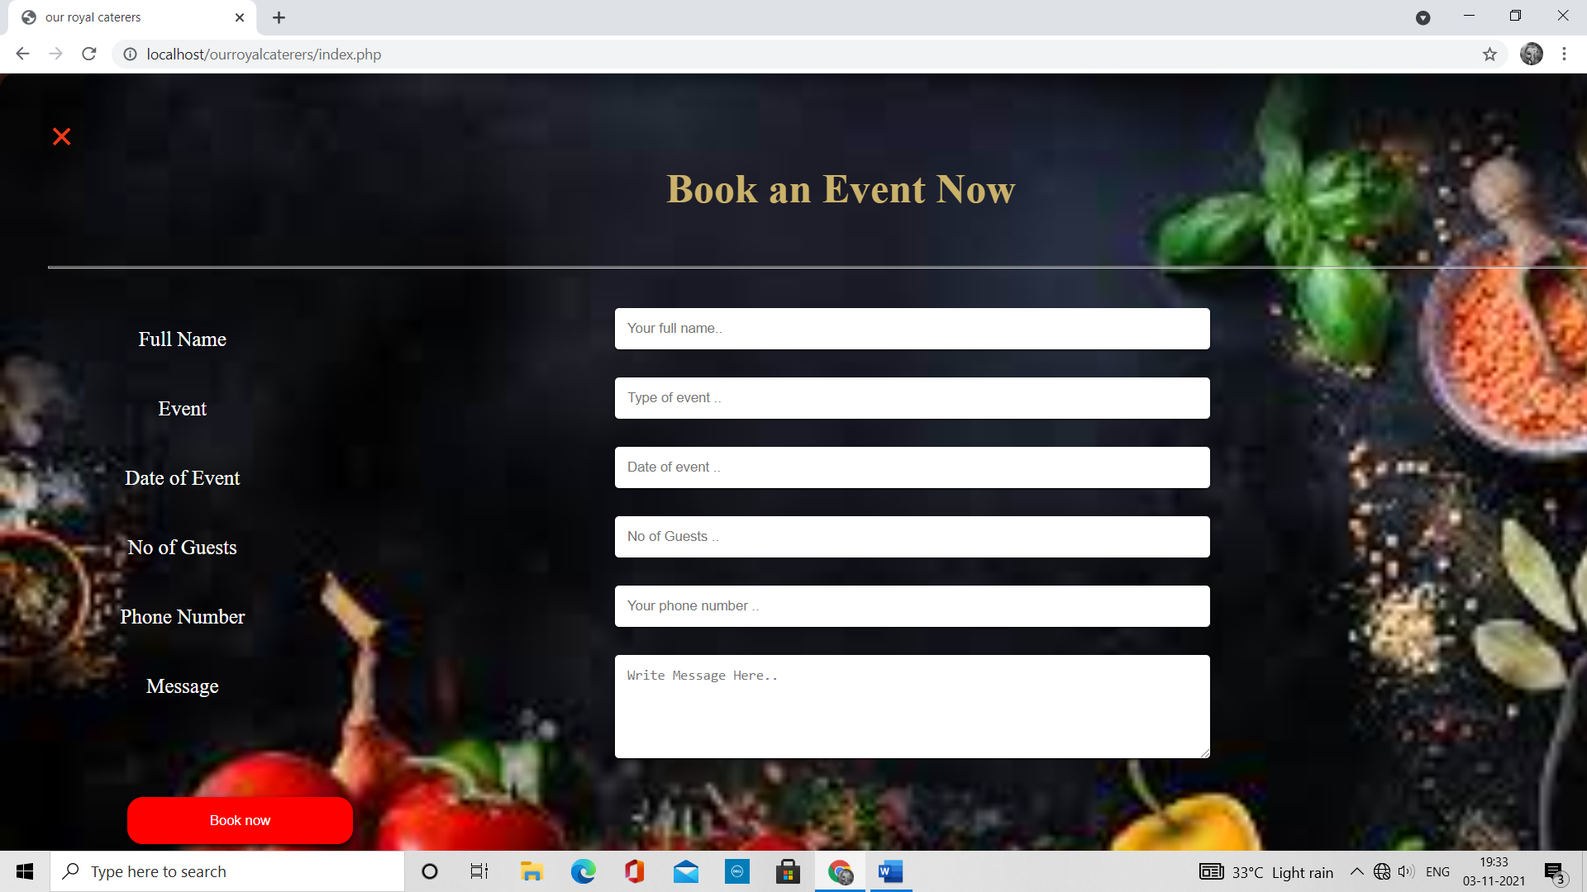

**Conclusion**

We conclude that our Project “OURROYALCATERES”is excellent and can be accessed from anywhere and anytime using Internet connected devices such as Phone,PC etc.

The main advantage of this project is customers can view and order our services using the website at their convenience.